Programming Assignment 1 – Intro Java (Sample IP Database)

Student: Thomas Pullar
Date: 02/04/2020

Unit: ICTPRG418
Teacher: Mark O’Reilly

Contents

IPO(Input Process Output) Chart 3
TOE (Task Object Event) Chart 4
Stylised Data Flow 4
Selected Pseudo Code 5
Displaying and Saving Records 5
DisplayRecord (CurrentRecord) 5
SaveRecord (CurrentRecord) 5
File data handling methods – read and write file 6
ReadFile 6
WriteFile 6
Navigation Button Code 7
First 7
Last 7
Previous 7
Next 8
Navigation Button Code 9
New 9
Save 9
Exit 9
Delete 9
Find 10
Structured Chart(s) 11
Managing the GUI elements 11
Managing the user Actions 11
Class diagram 12
Testing 13
Test Plan 13
Test Cases: 13
Evidence of Debugging 16
System generated program documentation 18
User Manual for: Sample Business Recycles 19

IPO(Input Process Output) Chart

Input | Process | Output | Storage
‘Records’ (entries) from the data file:  - Business Name  - Address  - Phone  - Website  - Recycles | - Open the file  - Read the first entry  - If not all entries have been loaded, load the next entry  - Record the total number of entries read in. | - Show first record (entry) on screen | Data File  Temporary storage in RAM memory
- New button, then…  - Business Name  - Address  - Phone  - Website  - Recycles  Then,,,  - Save button | - Clear the screen ready for new record to be entered.  - Allow user to enter information  - Save the record (entry) back to RAM memory | New record (entry):  - Business Name  - Address  - Phone  - Website  - Recycles | Updated records temporarily stored in RAM memory
- Search String and Find button | - Go through the record (entry) list until the Business Name matches the entry in the Search text field. | - Record (entry) is shown on screen
- Record (entry) to be deleted presented on screen and then the Delete button. | - For all entries after the current entry, move the other entries up the list, therefore removing the current entry.  - Set the number of entries in the list to current number – 1. | Present the next record (entry) after the deleted one. | Updated records temporarily stored in RAM memory
- Save button | - Save all the entries in RAM Memory into the specified output file. | Export of all records (entries). | All entries saved in a new copy of the data file.
- Exit button | - Save all data (as per Save button) and…  - Close program | Export of all records (entries). | All entries saved in a new copy of the data file.

TOE (Task Object Event) Chart

Task | Object | Event
Load Business record [0] | Form | Open
Clear screen ready for new entry | New button | Click
Save the current entry and then all entries to a clean copy of the data file | Save button | Click
Find the current entry | Find button | Click
Delete the current entry | Delete button | Click
Locate the first entry in the list and display it on screen | First (|<) button | Click
Locate the previous entry in the list and display it on screen | Previous (<) button | Click
Locate the next entry in the list and display it on screen | Next (>) button | Click
Locate the last entry in the list and display it on screen | Last (>|) button | Click
Save the current entry, then save all entries to a clean copy of the data file, and then close the program. | Exit button | Click

Stylised Data Flow

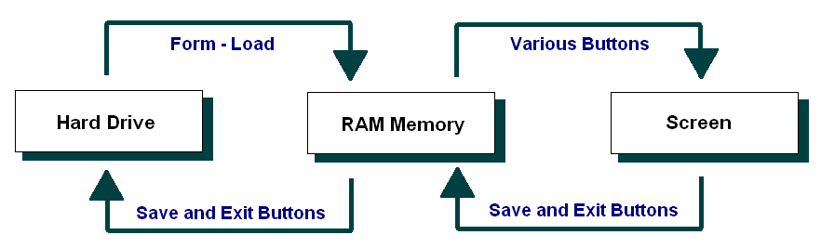

Selected Pseudo Code

Displaying and Saving Records

In line with our earlier data flow diagram and structured chart, we might start with a couple of the supporting methods that are called repeatedly.

In particular, let’s plan the method that Displays a Record, and the one that updates a record in RAM memory.

The pseudo code for these might be as follows:

DisplayRecord (CurrentRecord)

Copy the PC Name for the currentRecord to the PC Name text field
Copy the PC ID for the currentRecord to the PC ID text field
Copy the IP for the currentRecord to the IP text field

SaveRecord (CurrentRecord)

Copy the PC Name from the PC Name text field to the currentRecord of the PC Name Array
Copy the PC ID from the PC ID text field to the currentRecord of the PC ID Array
Copy the IP from the IP text field to the currentRecord of the IP Array

File data handling methods – read and write file

Next let’s turn to the file handling methods.

The pseudo code for these might be as follows:

ReadFile

If there is an error, then go to the ErrorHandler

Open the data file ready for reading
Set counter = 0
While there is more data
Read in a line of data
Put the entries in their respective arrays
Set counter = counter + 1
End While
Set the NumberOfEntries = counter
Close the data file

ErrorHandler:
Write the message: “There was a problem in loading the data in the data file”

WriteFile

Open the data file for writing data
For all entries in the arrays (For count = 1 to
NumberOfRecords)
Write a line of data into the data file
End For
Close the data file

Navigation Button Code

The navigation buttons - First, Last, Previous and Last - require code within the ActionPerformed method, calling other methods if/as required.

The pseudo code for these buttons might be as follows:

First
Set the CurrentRecord = the first record in the array
Call: DisplayRecord(CurrentRecord)

Last

Set the CurrentRecord = the last record entered into in the array
Call: DisplayRecord(CurrentRecord)

Previous
Set the CurrentRecord = the CurrentRecord - 1 in the array
Call: DisplayRecord(CurrentRecord)

That said, we need to check if we have gone past the beginning of the array... We therefore could adjust the pseudo code to test for this:

If CurrentRecord > first (0 for Java), then:
Set the CurrentRecord = the CurrentRecord - 1 in the array
Call: DisplayRecord(CurrentRecord)
End If

Next
Set the CurrentRecord = the CurrentRecord + 1 in the array
Call: DisplayRecord(CurrentRecord)

Again we need to check if we have gone past the last record (NumberOfRecords) in the array... We therefore could adjust the pseudo code to test for this:

If CurrentRecord < NumberOfRecords, then:
Set the CurrentRecord = the CurrentRecord + 1 in the array
Call: DisplayRecord(CurrentRecord)
End If

Note: The last record (last data entry) may be well short of the full size of the array. For instance there may be 67 computers in the arrays, but the arrays might hold up to 500 or 1000 entries.

Navigation Button Code

The remaining buttons – New, Save, Exit, Delete and Find - require code within the actionPerformed method.

The pseudo code for these might be as follows:

New

If the arrays are not full
Increment NumberOfEntries
Set the current record to the last record
Clear the array entries for the current record
Display the current record
End if

Save

Save the current record

Exit

Write the array data to the data file
Quit the program

Delete

For all records from the current to the last record
Copy the next PCName to the current record
Copy the next PCID to the current record
Copy the next IPAddress to the current record
End For
Decrement the NumberOfEntries
If the current entry is now past the new last entry
Set the current record back one
End if
Display the current entry

Find

Set found = false
Set counter = o
While you have more records to check and the entry has
not been found
If the current entry is equals to the search string
Set found = true
End If
Increment the counter
End While
If Found
Set the current record to the one that was found
Display the current entry
End if

Structured Chart(s)

Managing the GUI elements

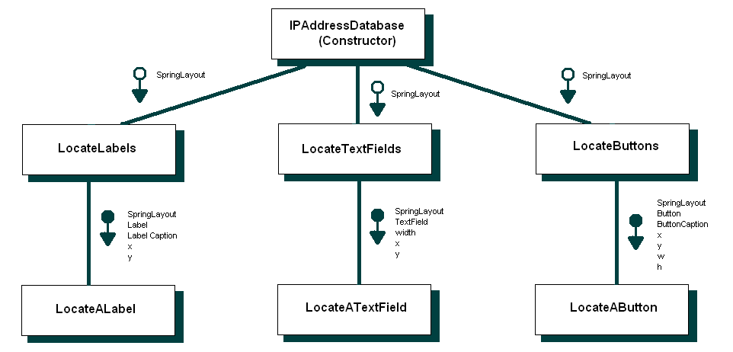

Managing the user Actions

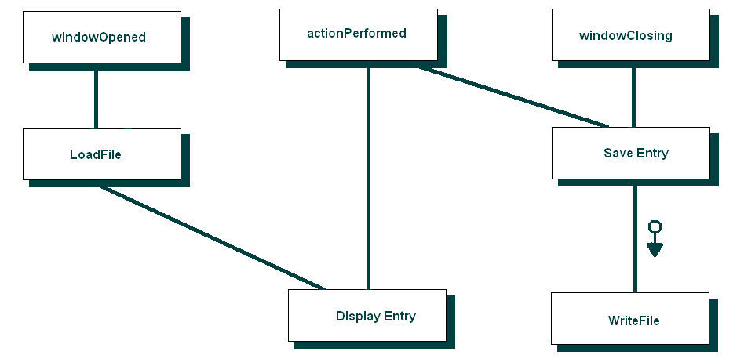

Class diagram
(Using ESSModel.EXE)
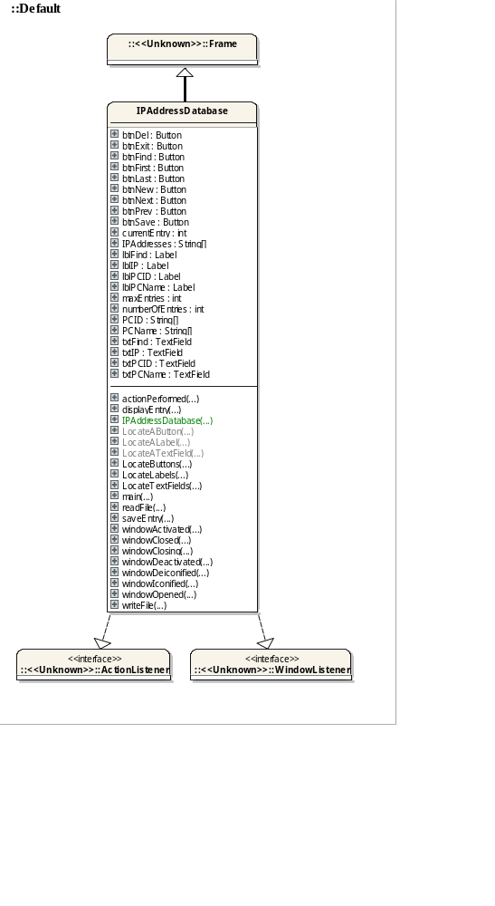

Testing

Test Plan

The approach to testing that will be used is as follows:

- Review the project requirements
- Prepare a solution design
- Develop the required application.
- Unit testing – test each component (method / class) as it is being developed
- Integrated Testing - Prepare a set of data (test cases) to check how the application will behave when appropriate data is read in and entered via the screen.
- Prepare several sets of data (test cases) to check how the application will behave when data that will generate exceptions is read in from the data file.
- Enter several sets of data (test cases) to check how the application will behave when data that will generate exceptions is entered via the screen.
- System Testing – Deploy the application to a computer system / network / web host site similar to that of the client’s and retest selected test cases.
- Acceptance Testing - Deploy the application to the client’s computer system / network / web host site and look to the client to retest using sample live data.
- Archive the test plan, test cases and results to an appropriate backup location.

Test Cases:

Sample data file 1 – Correct operation:
Polystyrene Recycler;27 Industrial St, Local Suburb;3232;www.polystyrene_recycler...;polystyrene
Local Recycler;81 Local Rd, Local Suburb;1234;www.local_recycler...;eWaste, plastic, metal, paper, cardboard, ...
IT Recycler;4 Tech Cres, Local Suburb;1122;www.IT_recycling_company...;computing hardware

Sample data file 2 – Testing for exceptions:
Polystyrene Recycler;27 Industrial St, Local
, Local Recycler;81 Local Rd, Local Suburb;1234;www.local_recycler...;eWaste, plastic, metal, paper, cardboard, ...
IT Recycler;4 Tech Cres, Local Suburb;Hello1122;www.IT_recycling_company...;computing hardware

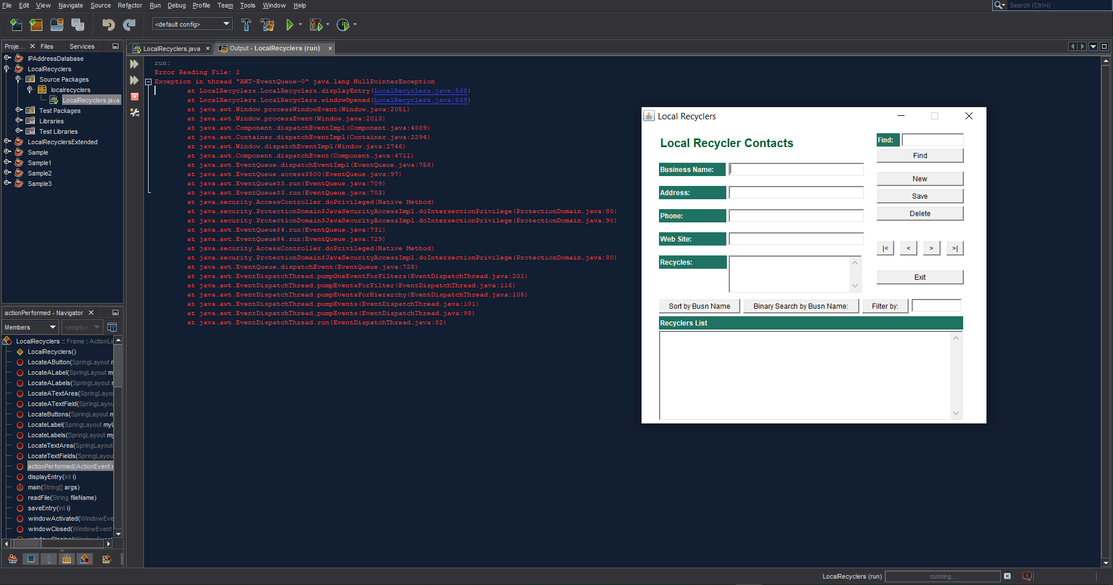

Additional sample data entries – Correct operation:
Polystyrene Recycler;27 Industrial St, Local Suburb;3232;www.polystyrene_recycler...;polystyrene
Local Recycler;81 Local Rd, Local Suburb;1234;www.local_recycler...;eWaste, plastic, metal, paper, cardboard, ...
IT Recycler;4 Tech Cres, Local Suburb;1122;www.IT_recycling_company...;computing hardware

Additional sample data entries – Testing for exceptions:
Polystyrene Recycler:27 Industrial St, Local Suburb;3232;www.polystyrene_recycler...;polystyrene
Local Recycler;”81 Local Rd”, Local Suburb;1w2w3w4;www.local_recycler...;eWaste, plastic, metal, paper, cardboard, ...
IT Recycler;4 Tech Cres, Local Suburb;1122;www.IT_recycling_company...;computing hardware
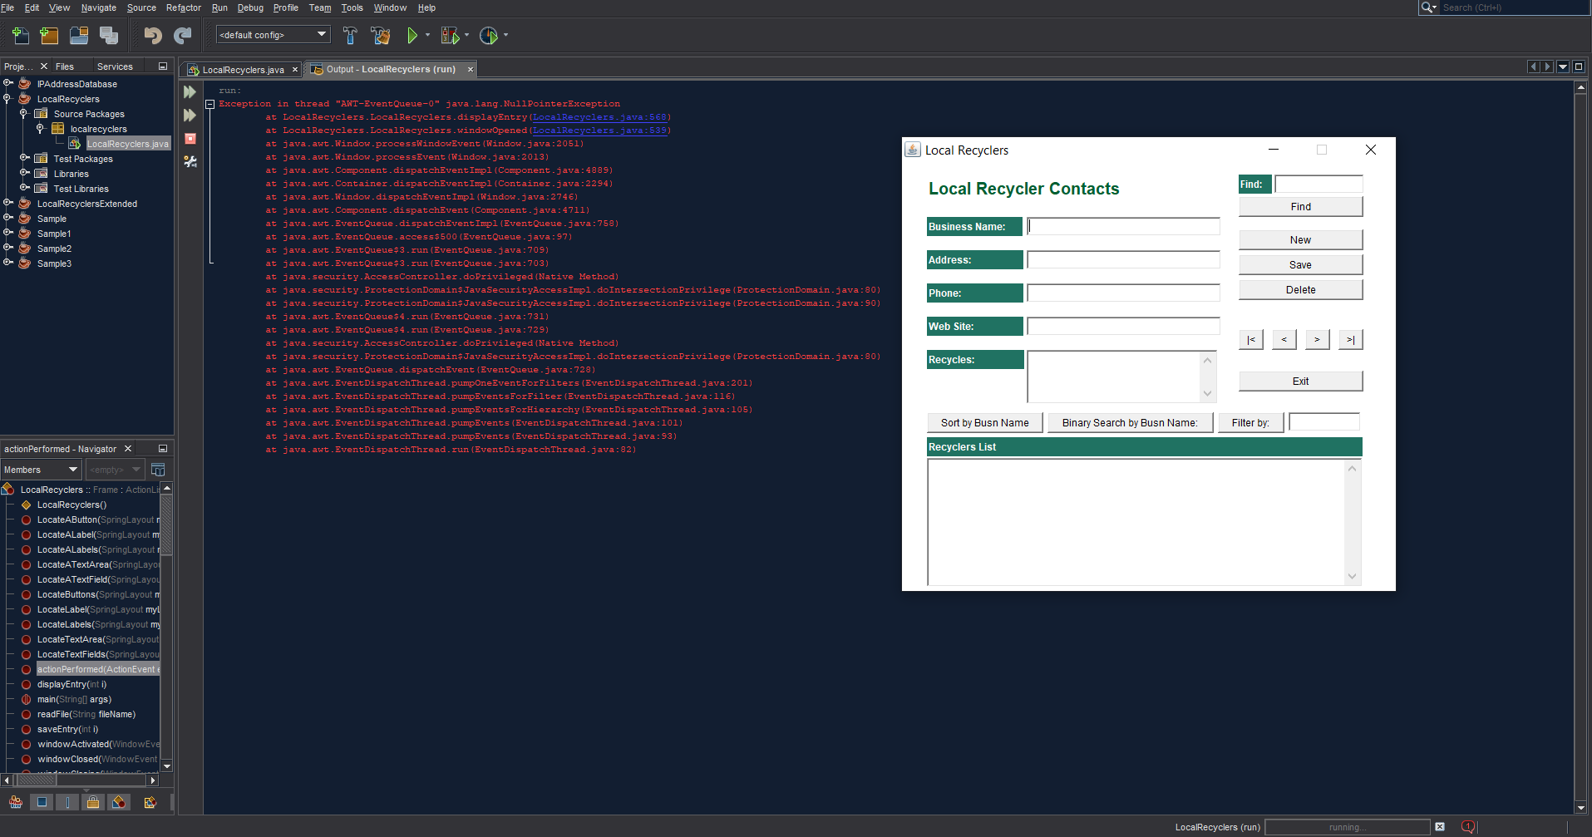

Additional tests of each of the application buttons:

      - Multiple click of ‘new’ button.
      - Click of ‘save’ button.
      - Multiple click of ‘delete’ button.

Results of testing (numbering correlated to the above tests):

- ‘New’: Created multiple new blank entries. This could be restricted to recognise empty fields and prevent further entries as to not create gaps in the register.
- ‘Save’: Information is not being stored into RAM or the output file. The writeFile method PrinterWriter line of code has been adjusted to save the changes over the original text file. The button save was also located within the button new. This was adjusted, along with minor other tweaks, and the result is a functional save button.
- ‘Delete’: Entries are able to be deleted, but it does not operate when trying to delete the first entry.

The tests above display the functional nature of the button and associated events. Although there may be improvements to reduce exceptions, overall the program is functioning reliably and as expected.

Evidence of Debugging

Two to three screen images demonstrating debugging:

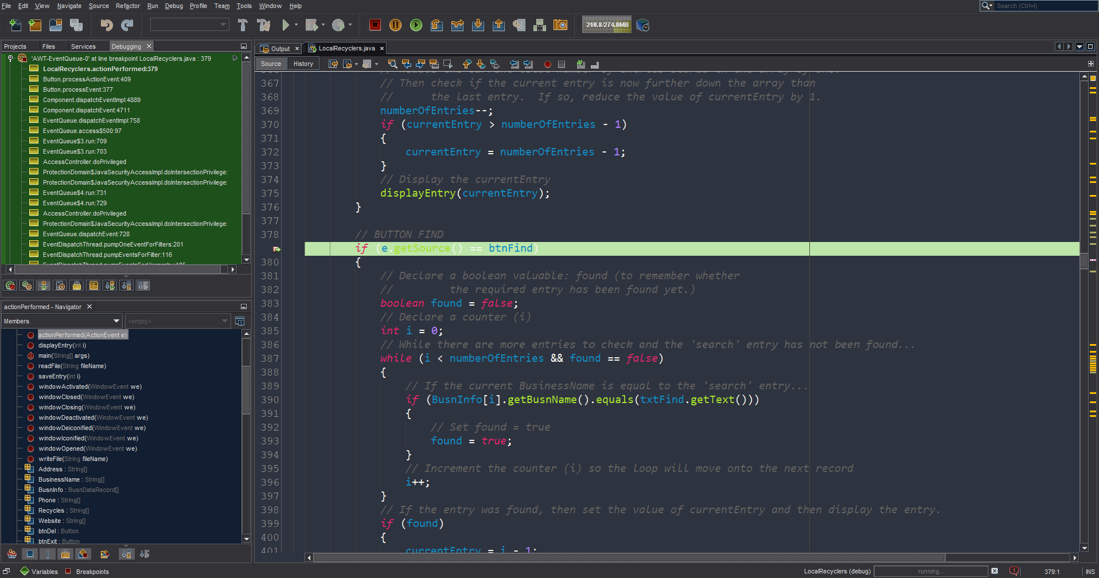
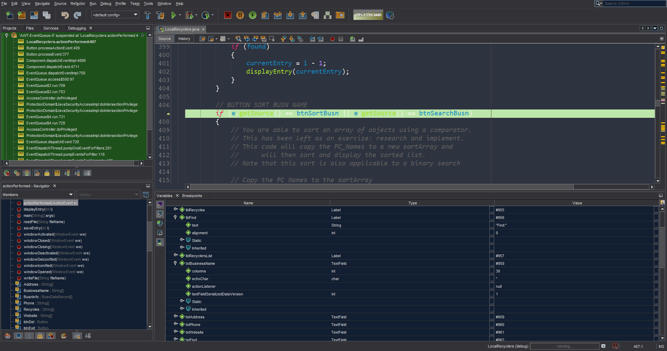

System generated program documentation

Prepare automated program documentation using a facility provided within your IDE, or using a separate facility such as Javadoc or ESS Model.

Submit this automated documentation in a separate zip file.

Data Entry Fields: These are text boxes for the user to enter any required information.

Data Modifying Fields: Buttons that the user may interact with to add, save or remove data.

‘New’ (Button): The user may select this button in order to make a new business record.

‘Save’ (Button): The user may select this button to save the data entered into the data entry fields. Note new records can be saved as well as updating previous records.

‘Delete’ (Button): This button enables the user to erase a record which reduces the total data entries by 1.

Data Navigation Tools: Buttons to assist the user in reviewing data sets based off an index number.

‘|< & >|’ (Button): These buttons display the first record (|<) or the last record (>|).

‘< & >’ (Button): These buttons take the current entry to the next entry (<) or the previous entry (>).

Search/ Filter Options: Buttons & keyword fields to assist the user in finding required data results.

‘Sort by Busn Name’ (Button): Sorts the Recyclers List field to display all Business names recorded.

‘Binary Search by Busn Name’ (Button): Displays the index result of the business name entered into the ‘Filter By’ text field.

‘Filter By’ (Button): Filters the Recyclers List field according to the characteristic entered (Busn Name, Address, Phone, Website, Recycles).

‘Find’ (Button & Field): A search function based off the company name.

User Manual for: Sample Business Recycles
Prepared for: Business Recycles
Author: Thomas Pullar
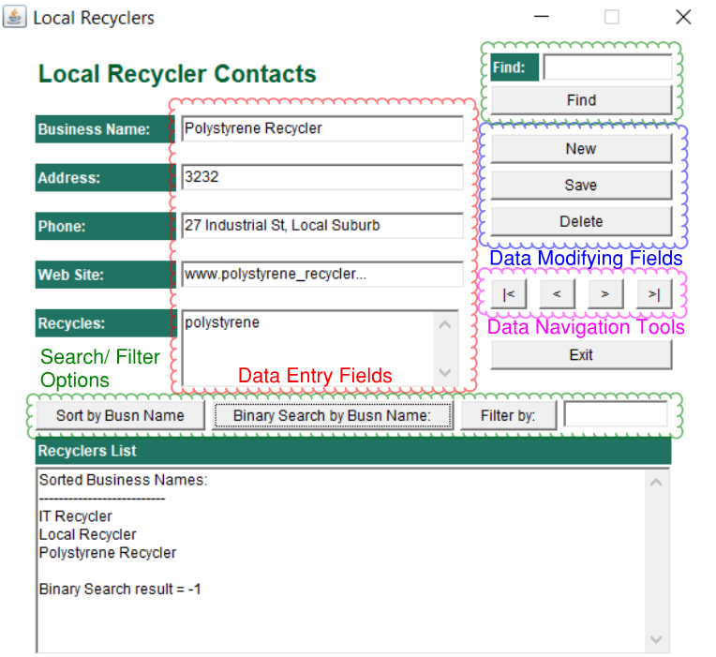
Date Prepared: 02/04/2020

